Project 1 Report – From Runbook to Copilot
For this project, I worked on creating and testing a runbook for restarting a service on a Linux system. I used an Ubuntu 24.04 virtual machine hosted in Microsoft Azure for my lab environment. The assignment examples referred to a service called ministry-web.service, but since that service was not available on my VM, I used nginx.service instead. I wanted to make sure I was working with a real service that I could actually test and verify.
I started by writing the runbook myself before looking at the AI-generated version. Following the confirm, capture, change, and verify process helped me organize the procedure in a logical way. First, I checked that the nginx service was installed and running by using systemctl status nginx. After confirming the service, I captured information about the current state of the system, including service status and log information. I then restarted the service and checked whether it came back online successfully.
The verification step was probably the most important part of the process. At first, I thought that if the service restarted successfully, the task was complete. However, while working through the project, I realized that a service can show as running and still not be working correctly. To verify that nginx was actually healthy, I used curl http://localhost and confirmed that the web page responded. This gave me confidence that the service was functioning properly after the restart.
Once I finished my own runbook, I reviewed the AI-generated runbook provided with the project. Some parts looked reasonable at first glance, but after comparing it with my verified procedure, I found several issues. One thing that stood out was the use of ministry-webserver.service, which did not match the service name used elsewhere in the document. I also noticed a recommendation to set worker_connections to 999999. That number seemed unusually high, and there was no explanation or justification for using it. Another command suggested deleting files from the journal log directory. I would not feel comfortable running that command because logs are often needed when troubleshooting problems. The AI-generated runbook also included a Restart value that did not appear to be valid for systemd.
I then tested the verify_runbook.py script against the AI-generated runbook. The linter successfully identified several questionable entries. It detected the invalid Restart value and flagged commands that could be unsafe or problematic. Seeing the script catch these issues showed how automated checks can help reduce mistakes and save time during reviews.
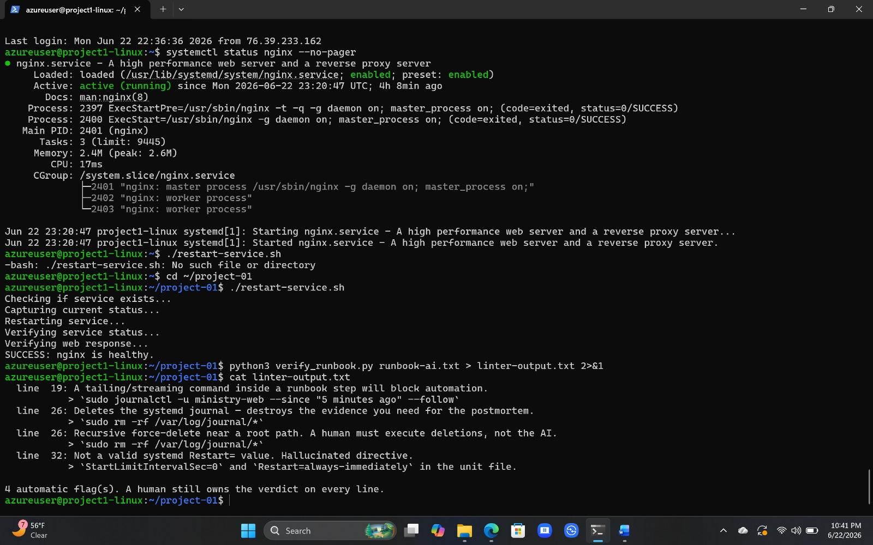
At the same time, I learned that automated tools have limits. The linter could not determine whether a service name actually existed on my system. For example, it did not recognize that ministry-webserver.service was not a valid service in my environment. This reminded me that scripts and tools can only check certain patterns. They cannot fully understand the context of a specific system. Because of that, human review is still necessary.
The biggest lesson I learned from this project is that AI can be helpful, but it should not be trusted without verification. The AI-generated runbook looked professional and well organized, yet it still contained mistakes and recommendations that could cause problems if someone followed them without checking. I think AI is useful for creating a starting point or draft, but system administrators are still responsible for testing procedures and making final decisions.
Overall, this project helped me understand the importance of documentation, verification, and careful review. It also showed me that while AI can assist with administrative tasks, it cannot replace the judgment and responsibility of the person managing the system.
AI Usage Note
I used ChatGPT to help me understand the project requirements and improve the organization of my report. The runbook itself was created and tested manually on my Azure Ubuntu virtual machine. I verified the commands in my environment and reviewed all AI-generated suggestions before including them in my submission.

